Sendero

Book Group Security --
Create separate groups for Dallas desk and New York desk, so members in one group cannot see information of the other group, also provide lock-out capability for certain users.

Current Settings --
Admin group: ADMIN
New York Desk Group: D7380
Dallas Desk Group: D0234
Dallas Settlement Group: S0234
Dallas IS Group: X0234

(Group designation: D = Desk, A = Audit, S = Settlement, X = IS Support)

D0234 (Dallas) personnel:
bhall, lmorvay, lwetzig, mjohnson, rdelasie, sstearns

D7380 (New York) personnel:
abarone, acaccioppoli, bcleary, jlando, mjohnson

X0234 (Dallas) personnel:
chuff, dchen, sfrench

S0234 (Dallas) personnel:
Mwhite, drafteseth

Admin personnel:
D0234, X0234, mjohnson, rsammons, rob.sammons

Setting up Book Group Security --
- Open Sendero.
- Go to Admin -> User -> Roles
- Go to the row marked with an asterisk (*).
- In the Role Code column enter a new role code for D0234.
- Press the enter key.
- Close the form and then reopen it.
- Make sure the radio button Functions For Roles is selected.
(Default, located at bottom of Admin-User-Roles winform)
- Expand the functions for this role by clicking the + sign next to D0234.
- Only certain functions are book group sensitive, the functions are:
  - AdminBooks
  - PositionBoxSummary
  - PositionContractBlotter
  - PositionDealBlotter
  - PositionOpenContracts
  - PositionRecalls
- Each function that can be assigned a book group will have a [NONE] in the Book Group List Column.
- There are three possible values for these functions:
  - [ALL] – Which will allow the user assigned this role to view/edit all book group information.
  - [NONE] – Which will not allow the user assigned this role to view/edit any book group information.
  - 0234;7380; - Which will allow a user assigned this role to view/edit the book group information for the book groups specified in the list.
- For setting up this role, we only want to give the user access to 0234. So for each function we will insert 0234; for the book group. Note: please insert total of 5 characters including the semicolon. Next check (enable) the [May View] and [May Edit] columns for all function paths except for those with Admin prefix.
- Check (enable) [May View] for AdminBooks function path.
When you finish it should look like the picture below.

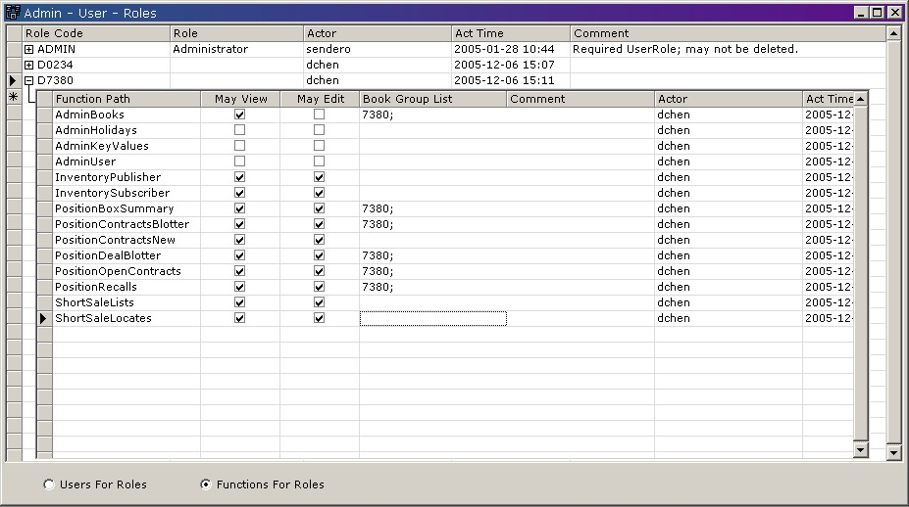

- Repeat the same process above (steps 1 ~ 13) for book group 7380, substituting 7380 for 0234.

- Go to Admin->User->Personnel.
- For every user expand the child grid by clicking the + next to the User ID, select the row if a role exists and press delete.
- Next inside the Role Code column and a drop down menu will appear. Select the role you want to assign to this user.
- Press enter.
- Then simply move off the row to accept the changes.
- Repeat the process for every user. No user should have the ADMIN role.
- If a user requires access to both book groups then simply assign them both roles.
--------

Screen Capture:

Admin – User – Roles
For Dallas Settlement Group S0234
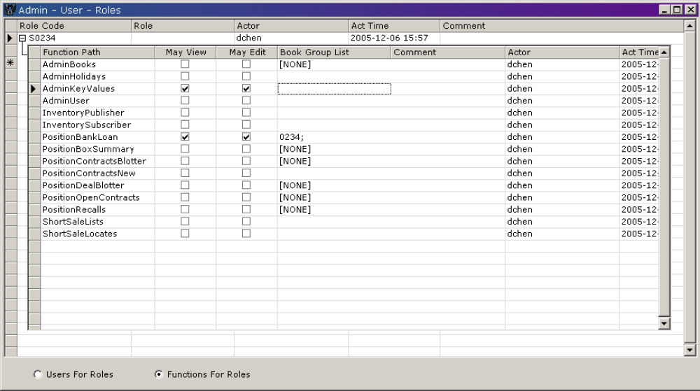

Admin – User – Roles
For Dallas IS Support Group X0234
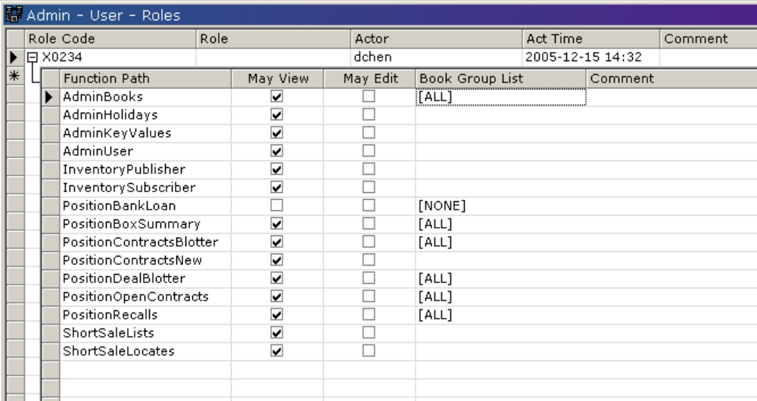

Admin – User – Roles
For Admin Group ADMIN
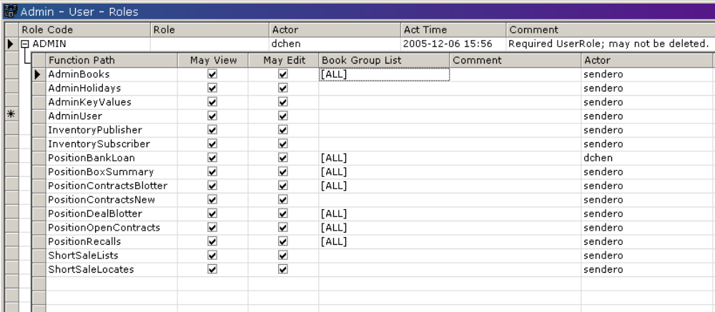

Admin – User – Roles
For Dallas Desk Group D0234
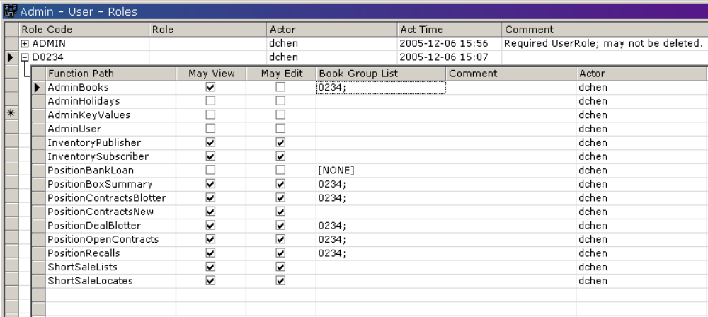

Admin – User – Roles
For New York Desk Group D7380
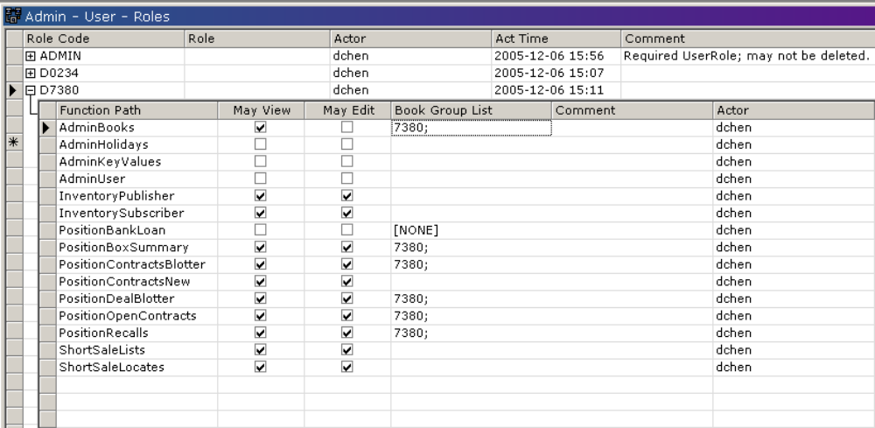

Admin – User – Personnel
